**Shiv Nadar University, Chennai**

**School of Engineering**

**Department of Computer Science**

CS1802 -- Programming in Python Lab Class: 2024-2028 B. Tech CSE (Cyber)

Date: 02/04/2025 Continuous Lab Evaluation – 9 (10 Marks)

**Statement:** To solve a system of linear equations using echelon form, which typically use Gaussian elimination and transforms the system into an upper triangular form.

**Task:** Develop a Python program that can solve system of linear equations using row echelon form (REF) and back substitution method.

Start with the file reading commands as below

file_pointer = open('sample1.txt')

array = [[x for x in line.split()] for line in file_pointer]

print(array[0][0][0]);

Here’s a step-by-step guide to solving a system of linear equations using echelon form:

**1. Write the System as an Augmented Matrix**

Consider the following system of linear equations:

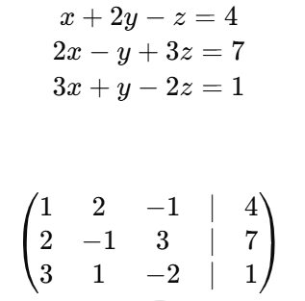

**2. Use Row Operations to Get Echelon Form**

Apply the following row operations to create a matrix in row echelon form:

* Swap rows.
* Multiply a row by a non-zero constant.
* Add or subtract multiples of one row to/from another row.

**Step 2.1: Make the leading entry in the first column a 1 (if it's not already).**

In this case, the first row already has a leading 1.

**Step 2.2: Eliminate the entries below the leading 1 in the first column**.

To eliminate the first column entries below the first row:

**Step 2.3: Make the leading entry in the second column a 1.**

To get a 1 in the second column, divide the second row by -5:

**Step 2.4: Eliminate the entries below and above the leading 1 in the second column.**

To eliminate the 2 above the second column:

* R1←R1−2R2

To eliminate the -5 below the second column:

* R3←R3+5R2

Finally,

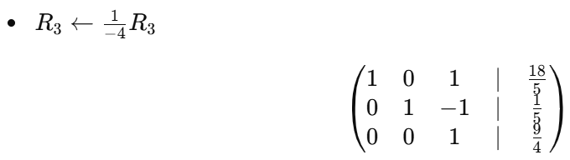

**3. Back Substitution**

Now that the matrix is in row echelon form, we can use back substitution to solve for the variables.

The matrix corresponds to the system of equations:

